Name *
First Name
Last Name
Email Address *
Age *
Height
Weight
Coaching Options *
Please Select Which Coaching Option You Are Looking For.
Promo Code
Please Fill in Any Active Promo Codes
Current Training Schedule *
(Sun-Sat. What Does Your Current Split Look Like? When Do You Go to The Gym? Cardio? Lifting? Training for A Half-Marathon? Any Programs You’re Following Like 5x5, 5,3,1, MADCOW, Smolov?)
Training Days *
How Many Days Per Week Can You Commit to Training?
2-3 Days
3-4 Days
4-5 Days
5-6 Days

At Home Training? *
Would You Like Any of Your Training Days to Be Catered Towards at Home Training?
One Rep Max Numbers *
(Squat/Bench/Deadlift) Put N/A If You Don't Have Any.
Current Fitness Level *
How Would You Describe Your Level of Fitness? Based on Both Physical Capabilities and Overall Knowledge? (Gym Equipment, Mobility, Warming Up for Lifts, Proper Form/Techniques Etc.)
Fitness Goals *
(Remember to Consider That Goals Should Me Measurable and Attainable... Do You Want to Add Weight to Any Particular Compound Movement Over the Next Few Months? Are You Looking to Build Muscle/ Lose Body-Fat? Etc.)
Biggest Strengths / Weaknesses? *
(In Regard to Your Fitness Level / Gym Life)
Personal History / Past Injuries / Anything Else:
Payment Options *
Please Select the Method of Payment You Wish to Be Billed Through (NO PAYMENTS WILL BE TAKEN THROUGH PROFILE SUBMISSION)

Waiver of Liability
This Agreement Releases Sam Brown/ Sam Brown Strength from All Liability Relating to Any Part of The Workout/Training Program He Suggests for Me. I Agree to Hold Sam Brown/ Sam Brown Strength Entirely Free from Any Liability, Including Financial Responsibility for Adverse Effects Experienced or Injuries Incurred, Regardless of Whether These Effects or Injuries Are Caused by Negligence.
By Signing Below, I Forfeit All Right to Bring A Suit Against Sam Brown/ Sam Brown Strength for Any Reason. In Return, I Will Receive Personalized Workout/Training Programming. I Will Also Make Every Effort to Obey Safety Precautions During Training. I Will Ask for Clarification When Needed.
By Filling Out And Submitting Your Full Name and The Date Below You Fully Understand and Agree to The Above Terms.

Name *
First Name
Last Name
Terms & Conditions *
I Acknowledge and Agree to The Terms Above
Date *
MM
DD
YYYY

Please Send this document back to sam@sambrownstrength.com and we will get started!
Thank you again for choosing Sam Brown Strength for your personal fitness needs
Stay Strong
Coach Sam
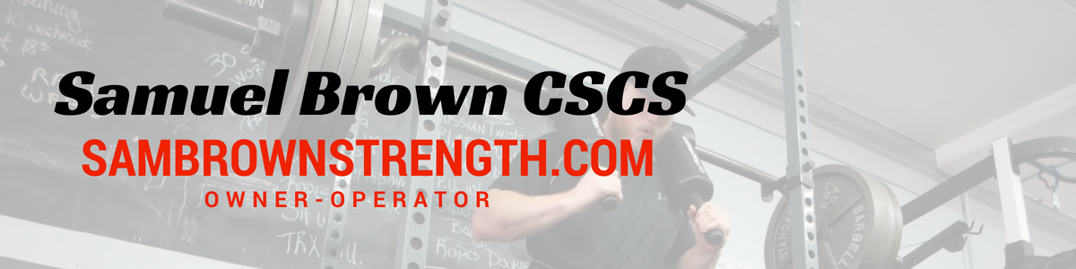
@SamBrownStrength

